***Submission Report Of JAVA Project on***

**Breakout ball**

**Cse – 310**

**JAVA Programming**



|  |  |  |  |
| --- | --- | --- | --- |
| Name | section | Roll No. | Reg NO, |
| Fanish Pandey | K21ZN | 46 | 12102636 |
| Kramash Gupta | K21ZN | 58 | 12111386 |
| JIteshwar Singh | K21ZN | 59 | 12111442 |

Submitted To: Mrs. Chandni Bhasin

***Acknowledgement***

This is to acknowledge all those without whom this project would not have been reality. Firstly, we would wish to thank our Computer Science teacher (Java Programing) **Mrs.Chandni Bhasin** mam who gave his immense support, dedicated his time towards it and made us understand how to make this project. Without his guidance, the project would not have been completed.

The Independent, and the statistical data has been extracted from school database ( books from Library ) and from Internet facilities.

***Introduction***

In this report file, we are going to discuss step by step process to create a Breakout ball game using Java.

In this game, there is a layer of bricks lines that covers the top third of the screen, a ball, and a paddle. A paddle moves horizontally to bounce the ball back upward keeping it playing. When a ball collides with a brick, it bounces back and destroys the brick. The player loses a turn when the ball touches the bottom of the screen. The goal is to break all the bricks without missing the ball.

In this basic knowledge of Java Swing and OOPS concepts should be there to make this project.

First of all, to create this project we set up the development environment for the Java GUI project by java compiler or any other code editor.

## Steps involve:

1. Design the game window.
2. Design the gameplay (background, bricks, ball, and paddle)
3. Implement the actions of the keys (to move the paddle sideways).
4. Implement the action performed by the ball on the bricks and paddle.

## Goals to be achieved at the end of the game:

1. The player should be able to start the game by pressing the ENTER key.
2. The player should be able to move the paddle horizontally using left and right arrow keys on the keyboard.
3. Once the player loses the ball, i.e. when the ball touches the bottom of the window, the game ends.
4. Breaking each brick should provide the player a certain score. Let’s say each brick contains 5 points, if a player breaks 10 such bricks, he gets a score of 50.
5. At the end of the game, the terminal will present the player’s final score and give him the option to restart the game again.

In our game, we have one paddle, one ball, and 36 bricks. We have created a ball, paddle, and brick using graphics class in java. To create the game cycle, we will use the Timer class. For the sake of simplicity we are not working with angles, we simply change directions to top, bottom, left, and right. The game consists of three files: Main.java, Gameplay.java, and MapGenerator.java. We will talk about each class in detail. So, let's get started.

***Step by step procedure to make this project.***

**1. Design the game window**

Firstly we created a java project name Breakout-Ball . Inside that project folder, created a package and class Main.java with the main method. In this main method, we created and design a game window. Here, we have also created an object of gameplay to run the game which will be discussed further in detail.

Code for the main page

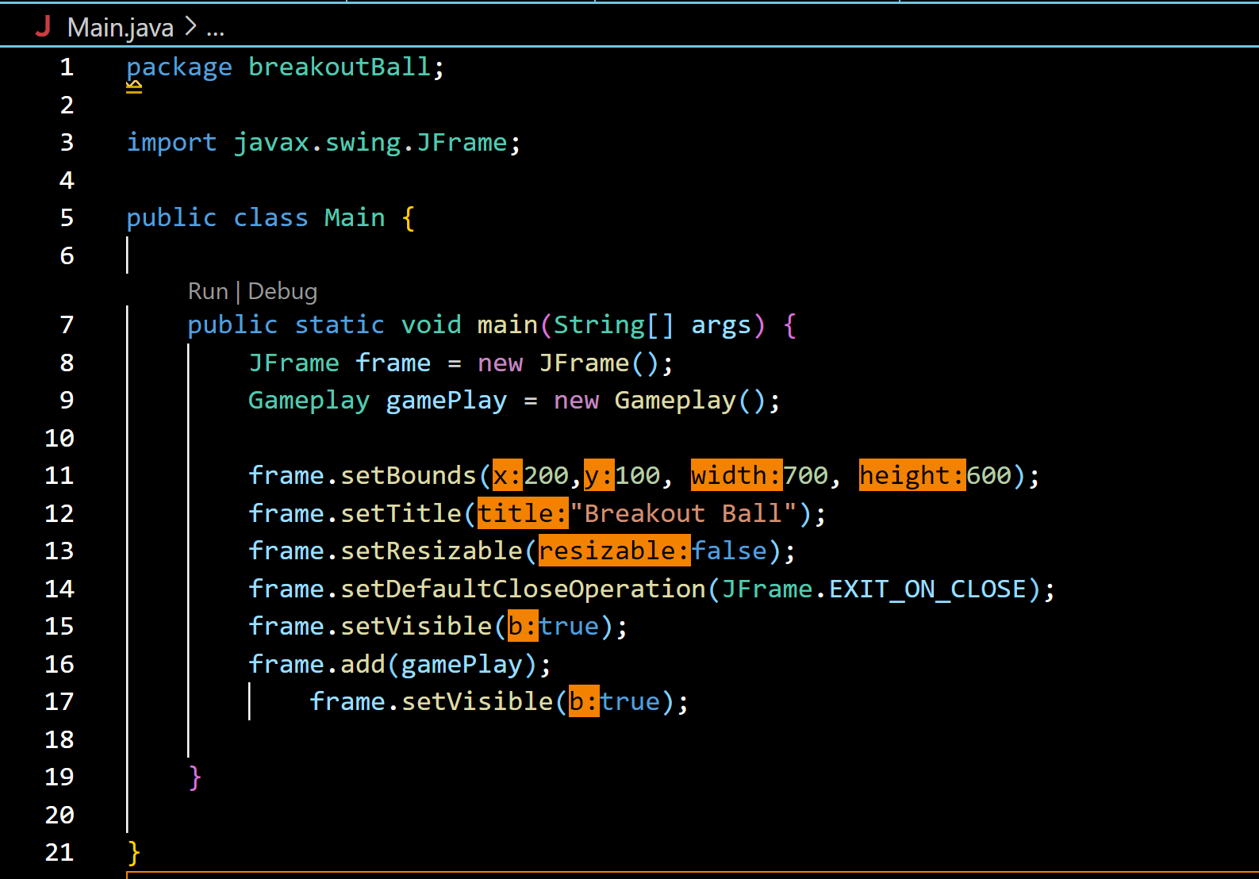

Output for the code of main page

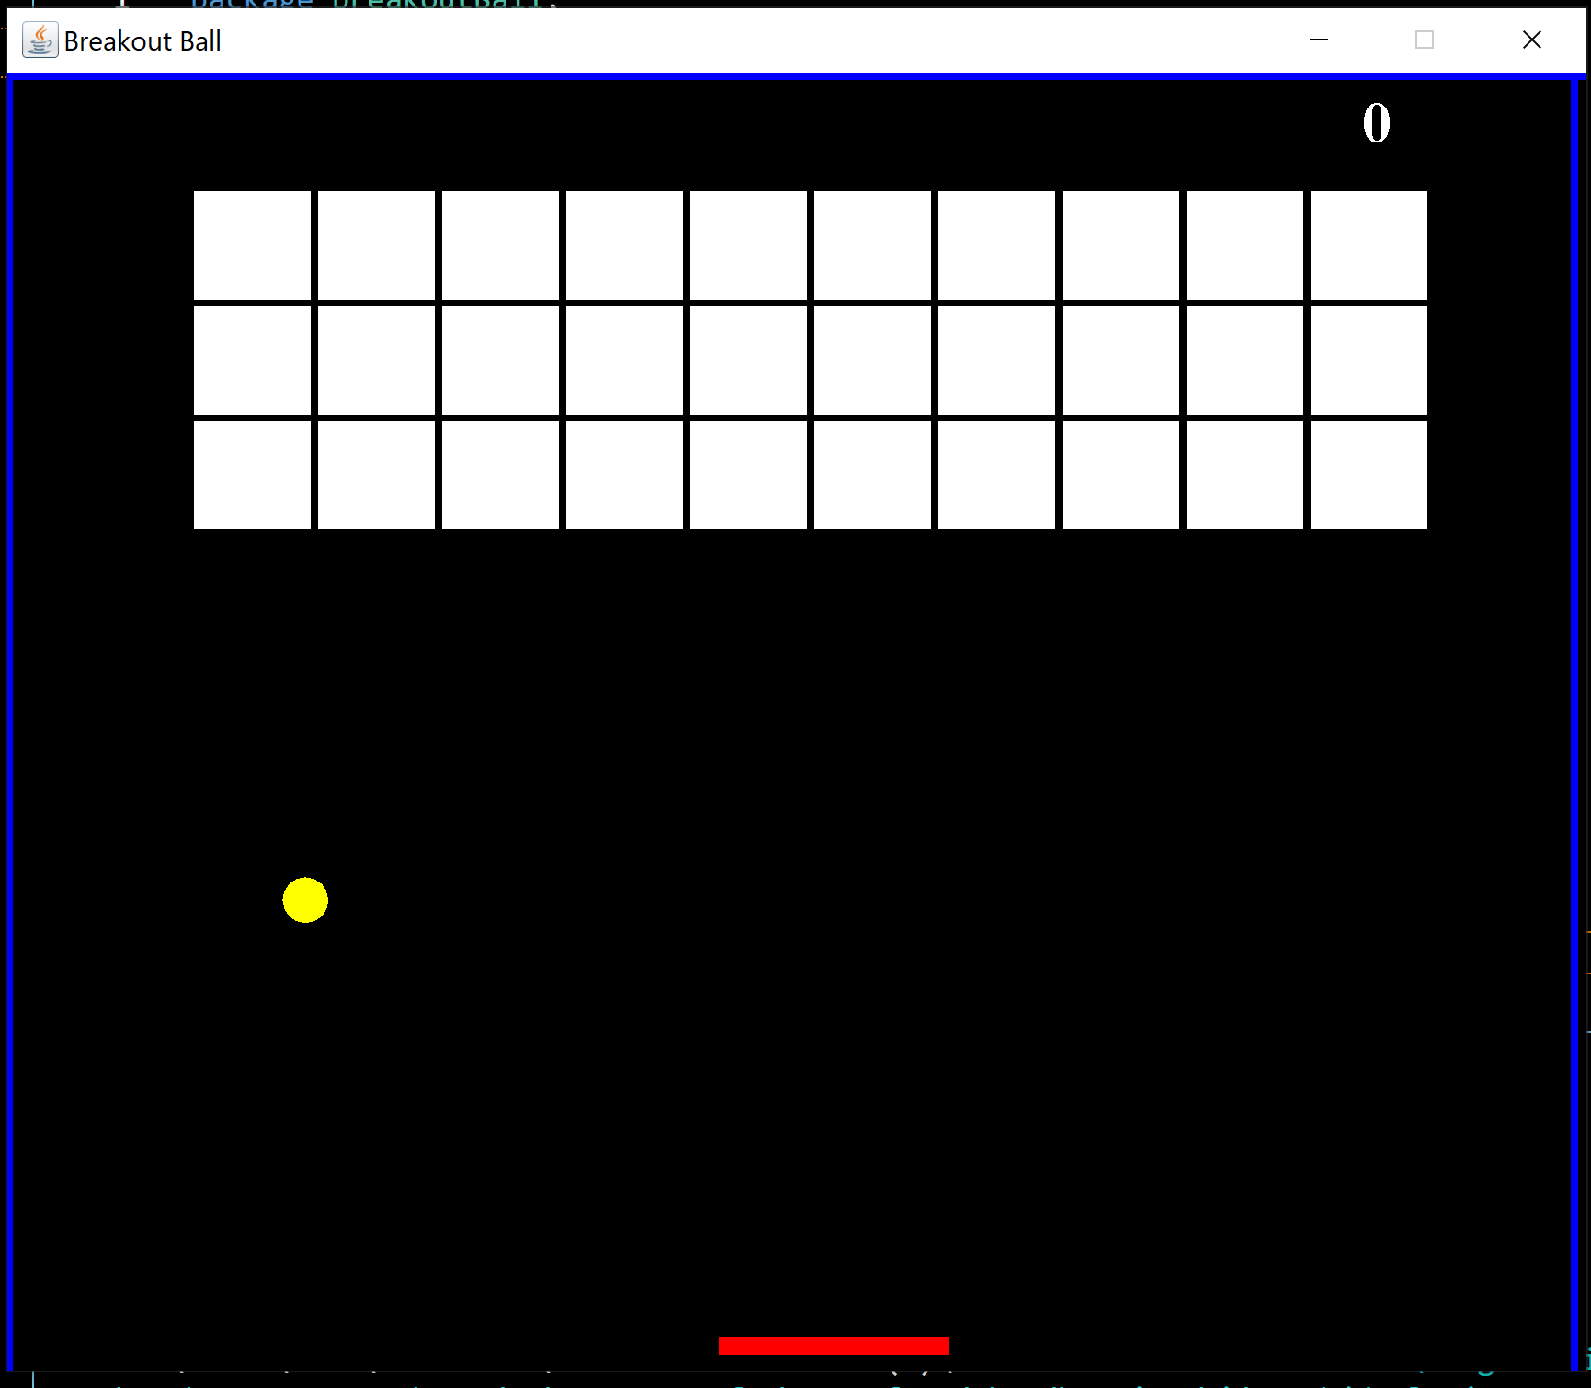

**2. Designing the gameplay**

We have created a new class Gameplay.java inside your package which extends JPanel. This class will be the panel where the game works. Firstly, we will define some common properties of the game. We are using the Timer class for setting the speed for the ball. Then create a public method paint to draw paddle and ball using Graphics.

Code for the game play

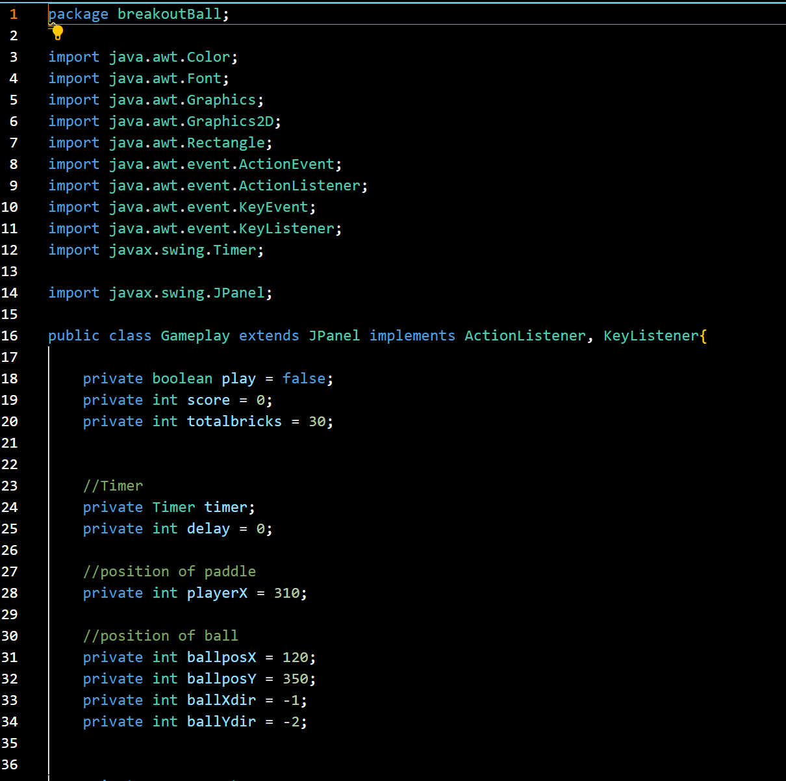 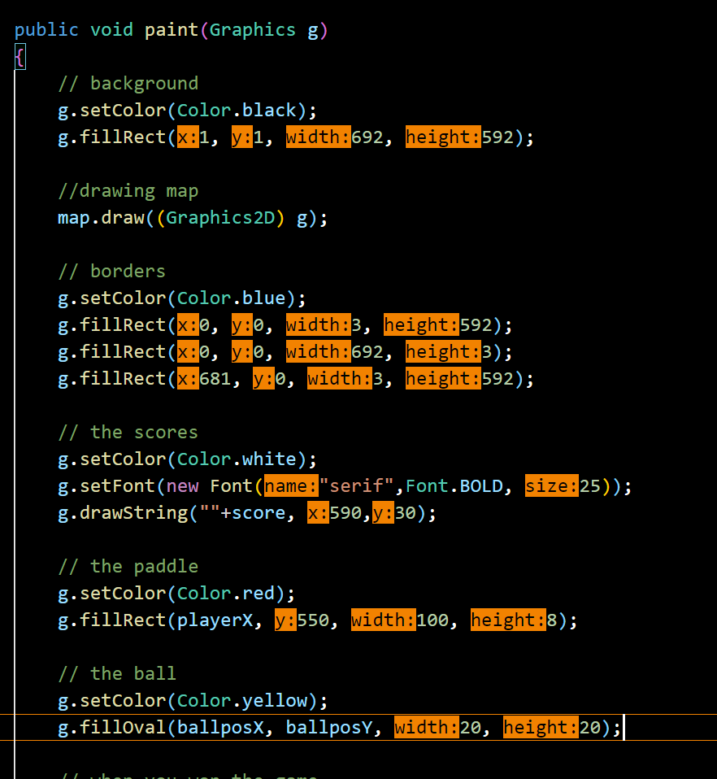

To draw the bricks, we created MapGenerator.java class inside our project folder. Here we are using a generic map for drawing bricks, so it does not remain static and can be changed if you want. We have to call the draw method in the above paint method to draw bricks.

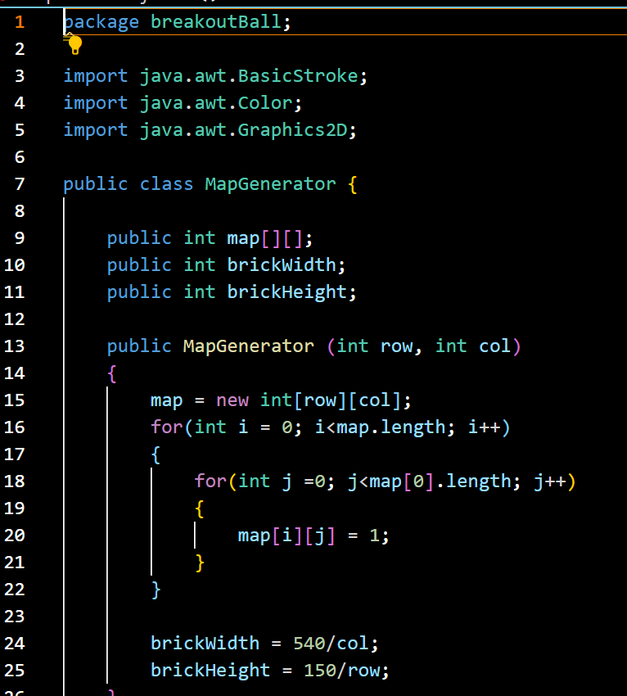

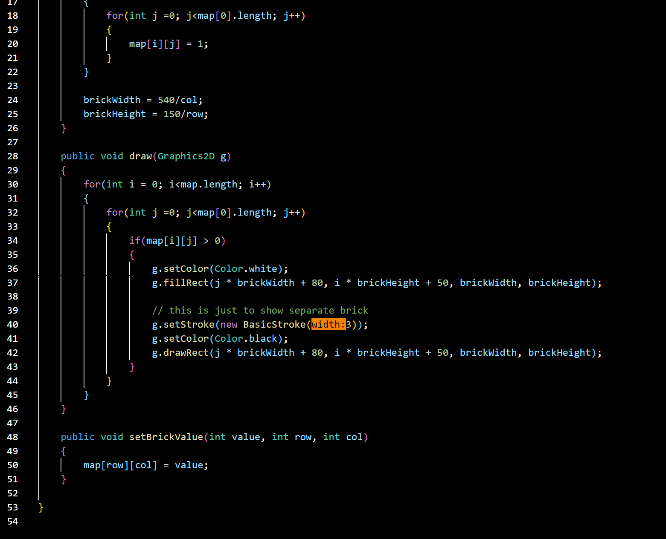

# 3. Implement the action of the keys

Now, to detect keys and their actions, we have to implement KeyListener and EventListener interfaces to our Gameplay class and add all the unimplemented methods. We will implement key pressed to move paddle horizontally using left and right arrow keys.

Code for Implementing the actions of keys

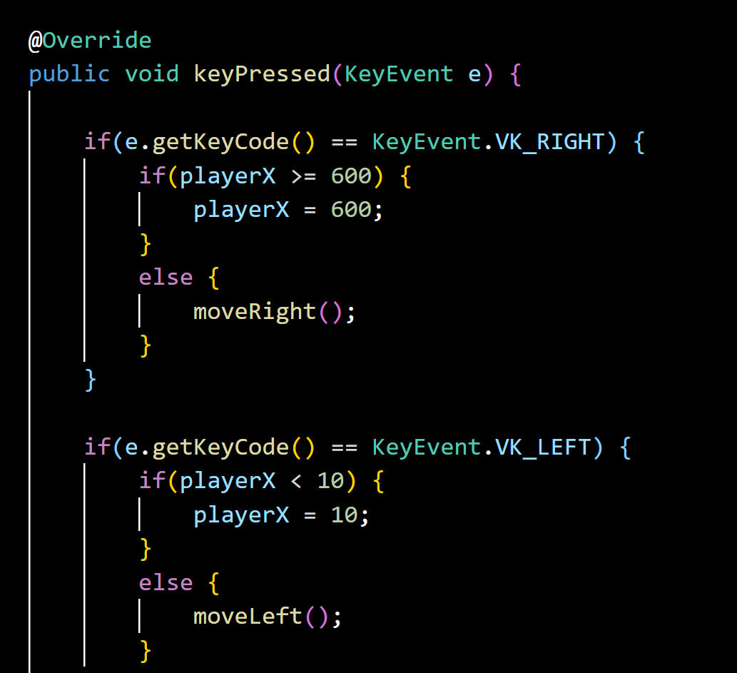

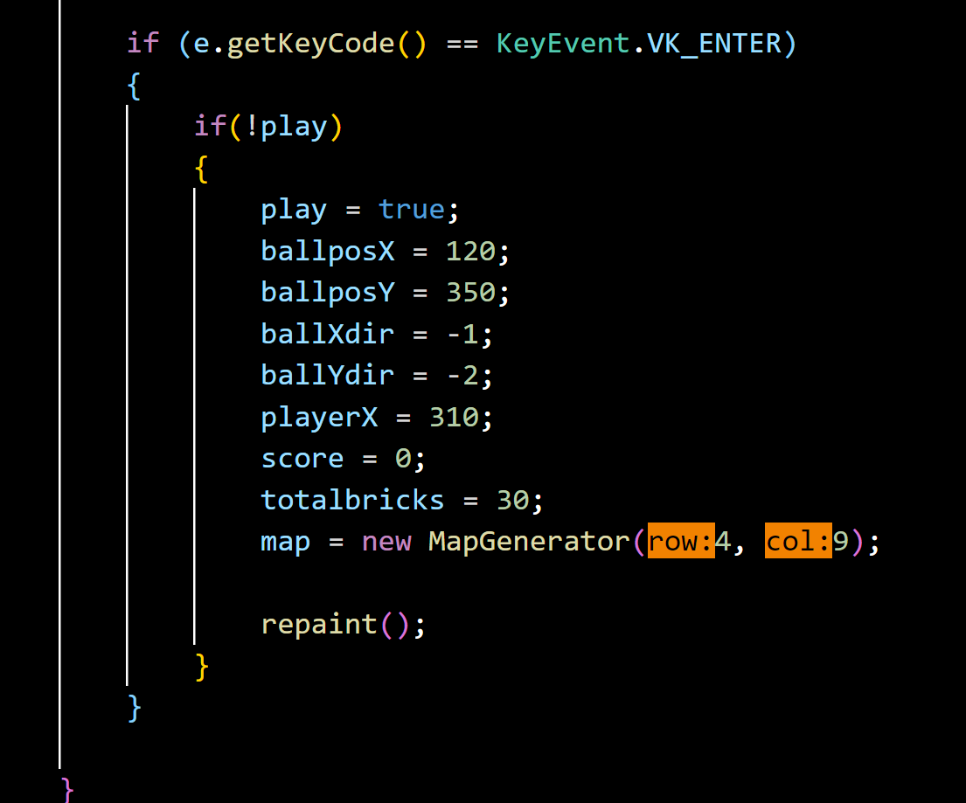

# 4. Implement action performed by the ball on the bricks and paddleWhen the game is started, in order to move the ball, we have to detect if it’s touching left, right, or top of the panel and change its direction accordingly. Then, we have to find the collision between the ball and the paddle, and the ball and the map. For detecting collisions between two objects, we need a rectangle, so we have to create a rectangle around the ball as it is oval.

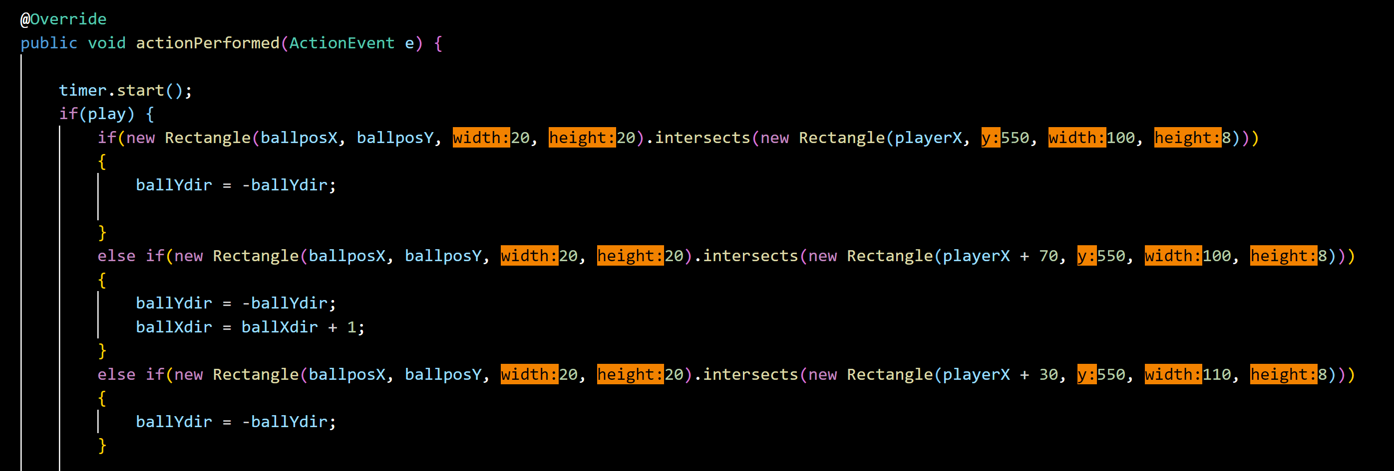

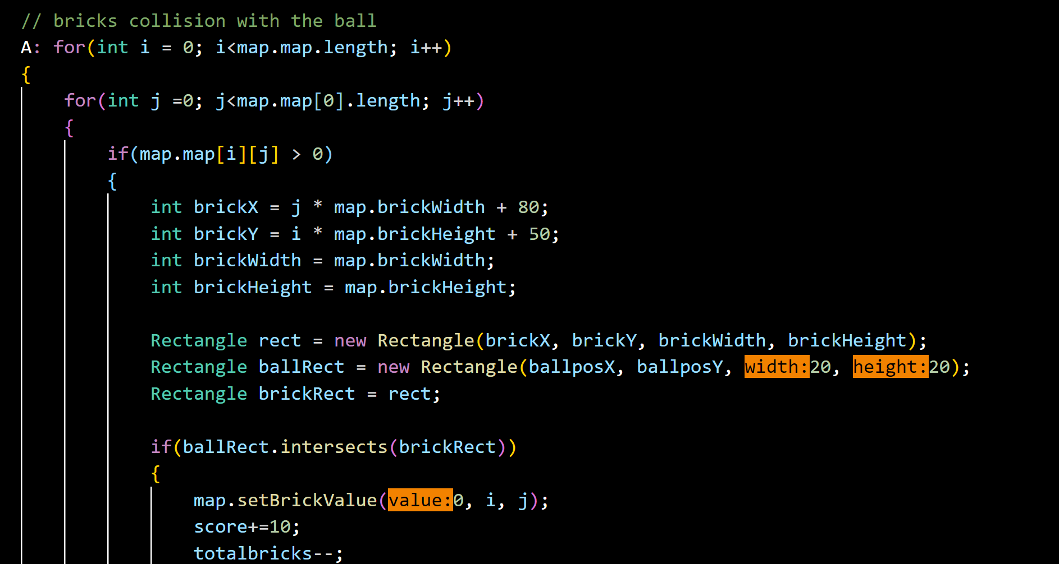

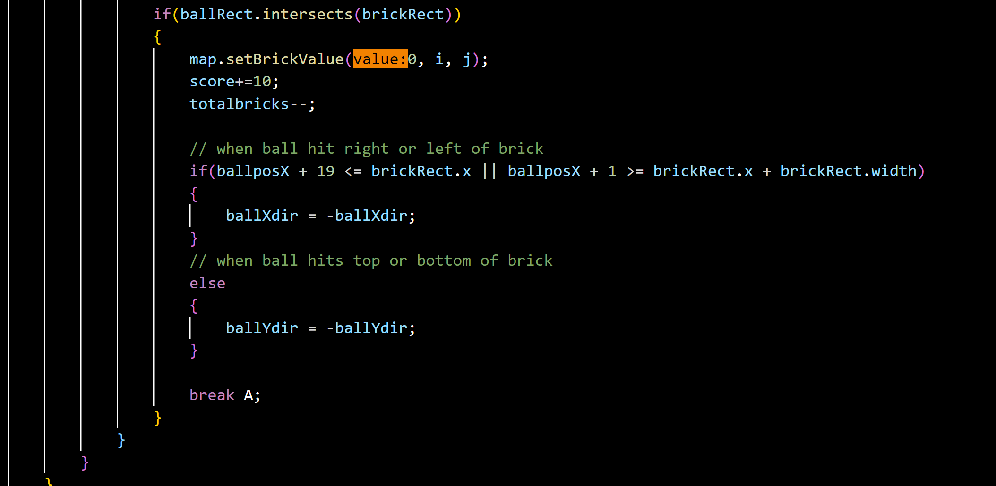

When the ball intersects the brick, we have to break the loop so we have used a label to break the loop. If we use the break keyword compiler will only take you out of the inner loop but we want to out of the outer loop that is why we have used labels. We have called the repaint() method to redraw paddle, ball, and map after every movement.

# 5. Displaying result

Inside the paint() method of Gameplay class, add a score and result when the game is over.

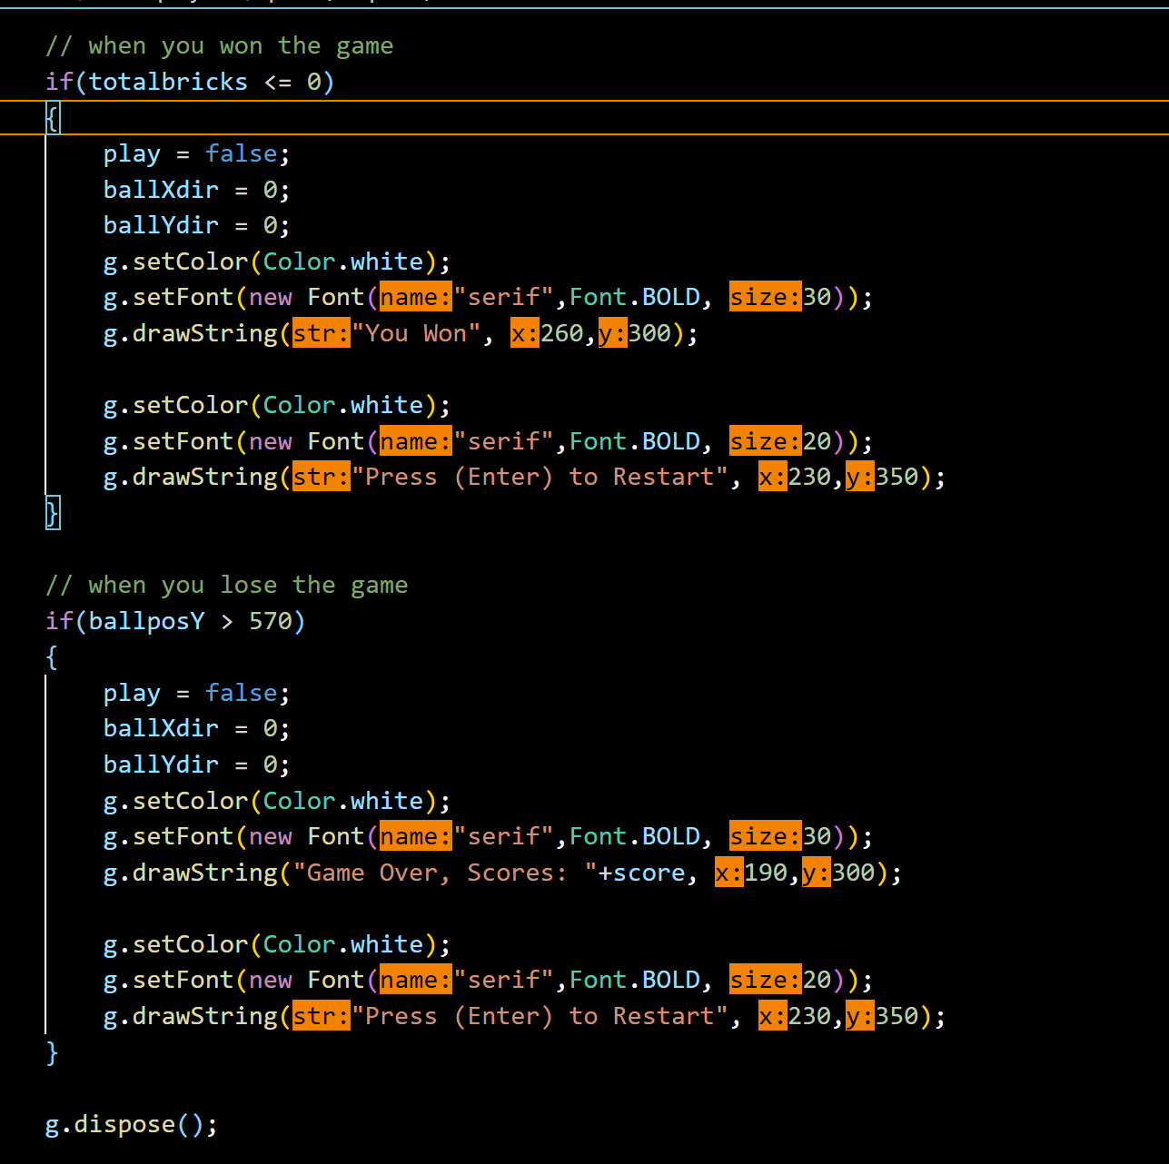

*References:*

* Took help from the Google and YouTube for learning the basic concept of this game.

<https://www.youtube.com/edit?o=U&ar=1..>.

<https://www.freecodecamp.org/news/code-a-2d-game-engine-using-java/>

* Took help from the Books which are provided to us by university for syllabus specially for Methods and classes.

PROGRAMMING WITH JAVA: A PRIMER, 4E by E. BALAGURUSAMY, MCGRAW HILL

. INTRODUCTION TO JAVA PROGRAMMING by Y. DANIEL LIANG, PEARSON.

JAVA THE COMPLETE REFERENCE by HERBERT SCHILDT, MCGRAW HILL EDUCATION

***GITHUB Link:*** <https://github.com/Fanish2952/Brakout-Ball-Game>